Page 0

Dear Hasan,

I had reviewed your the ICC conference paper itself. But I want to have some deep consideration to improve the practicability of the research content. So, I'll list my considerations below.

LI Qiao

2021-2-11

Dear Hasan,

I had reviewed your the ICC conference paper script and made notes in the Word file. But for a higher requirement, I think some assumptions and applications should be considered as:

1. A reasonable scenario for engineering – the compress process shall not take in every time because compressing should cost time for buffering the data and re-packeting and computing ( even though overhead of the dictionary generating and transferring can be omitted ) The compress operations might happen properly when packets were blocked by the higher priority traffic ( such as CDT ) or were blocked by the front blocked traffic.
2. The benefit will be considered not only for average performance, but for the worst case, such as some analysis under service curves in Network Calculus.

Therefore I wrote some pages for you. Some of them were written by hand and are pasted in prictures ( because of no computer during the days of preparing the Spring Fesiteval, and pages in the rear are in Word format and some figures were got by MATLAB codes.

You can consider whether merge these assumptions discussed in the following pages to the ICC conference paper.

Sincerely

LI Qiao

2021-2-14

Btw: in your script, major issues were marked “[Major]”.

Page 1

**1 COMPRESS-AND-FORWARD MODE**

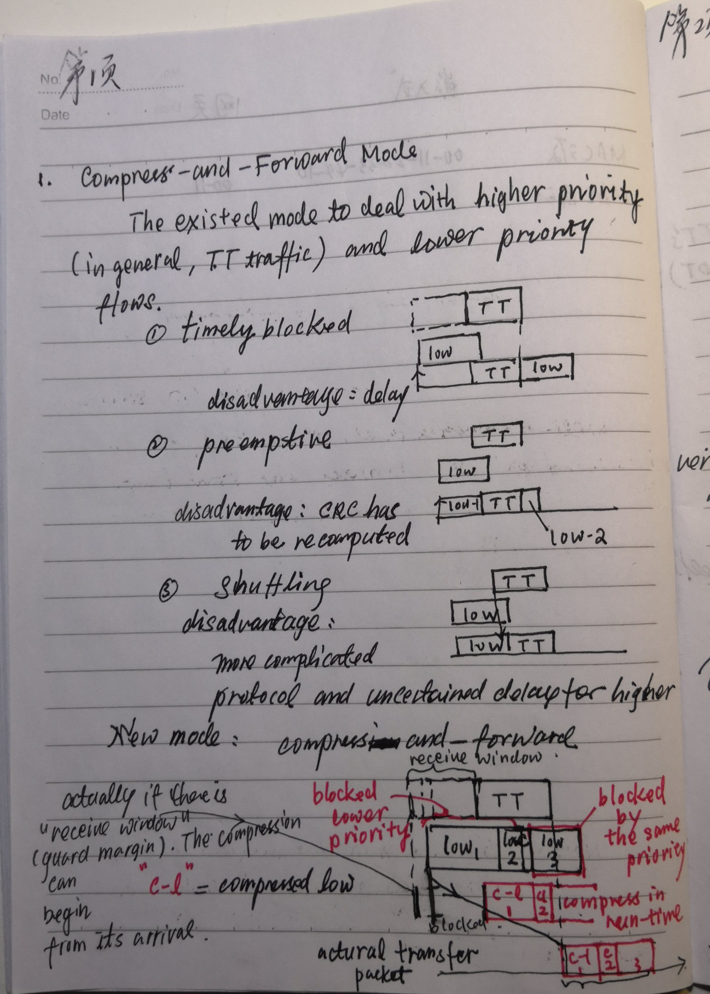

Page 2

**2 THE LENGTH OF PERIOD TO BE USED FOR COMPRESSION**

When met the CDT period in TDMA-based GCL, to compress blocked lower priority packets and forward. ( Compress-and-Forward, CaF )

**2.1 Compress-ratio**

**2.2 Overhead considerations**

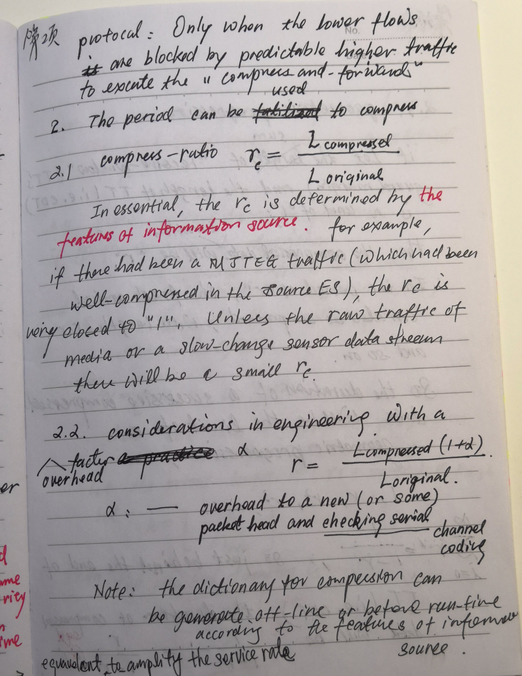

Page 3

**2.3 Geometric progression**

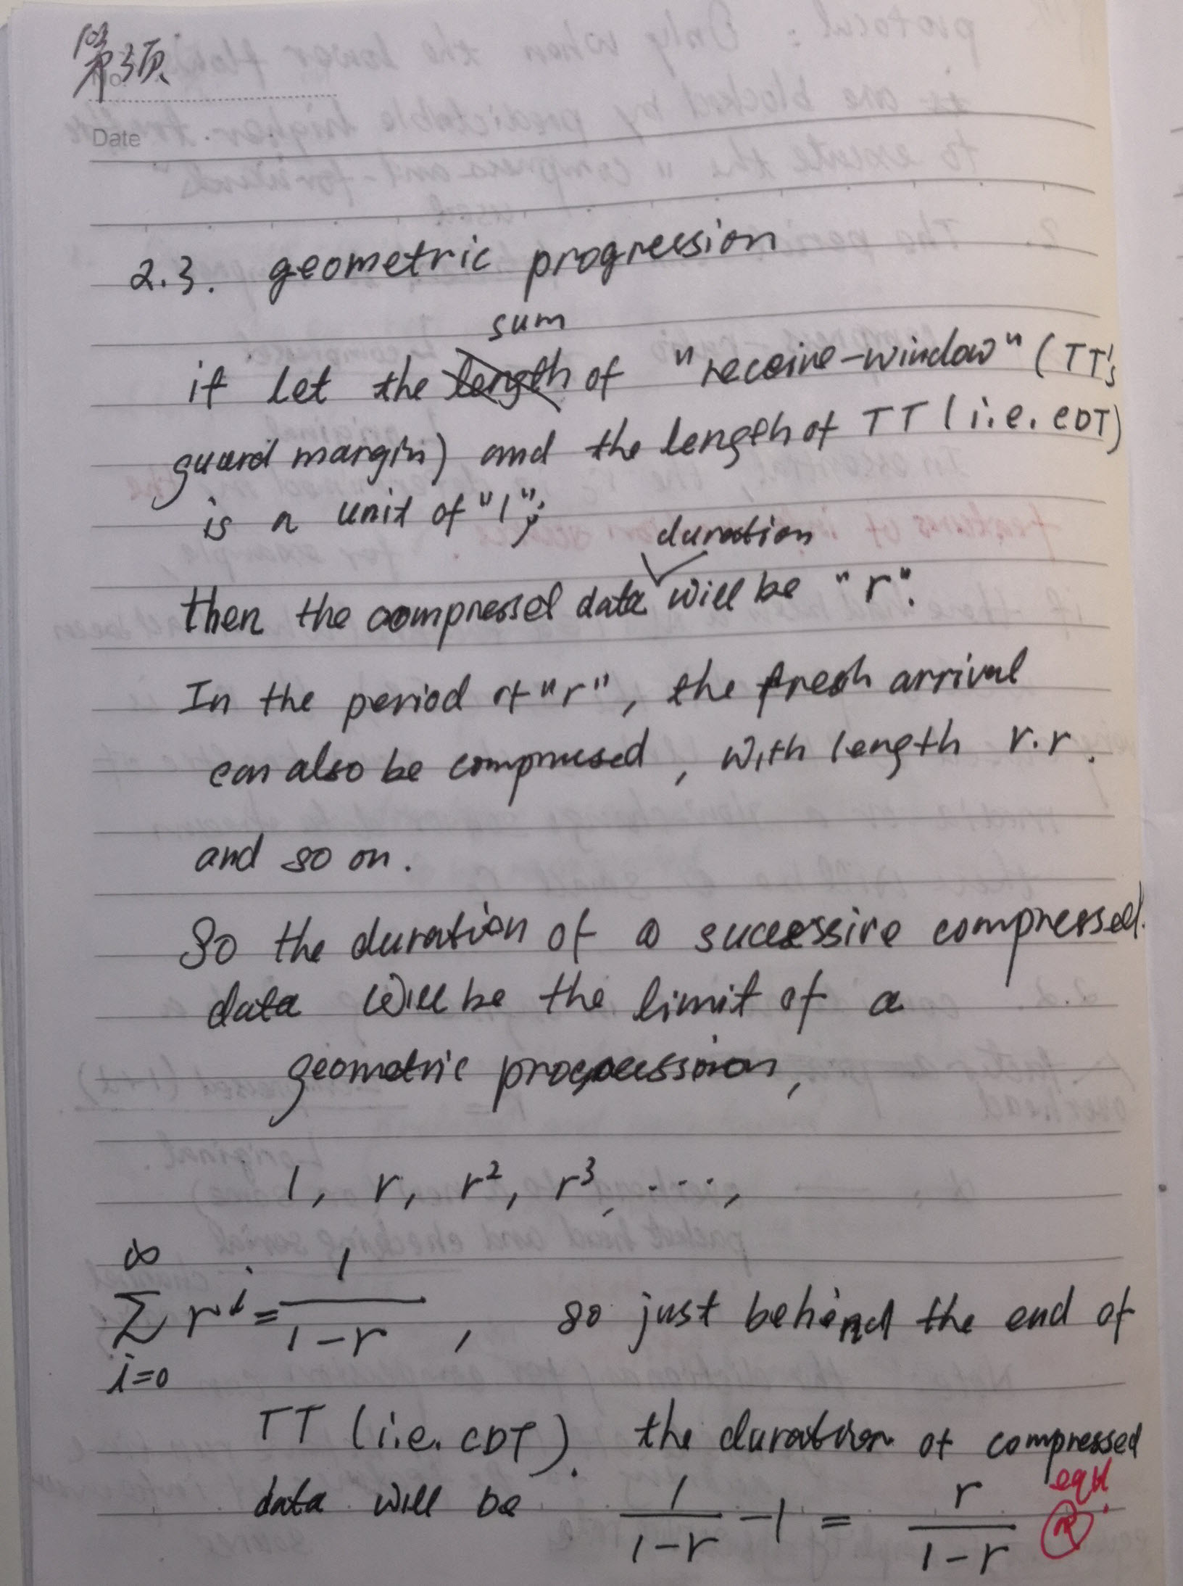

Page 4

**2.4 Smallest buffered block to the length of compression period**

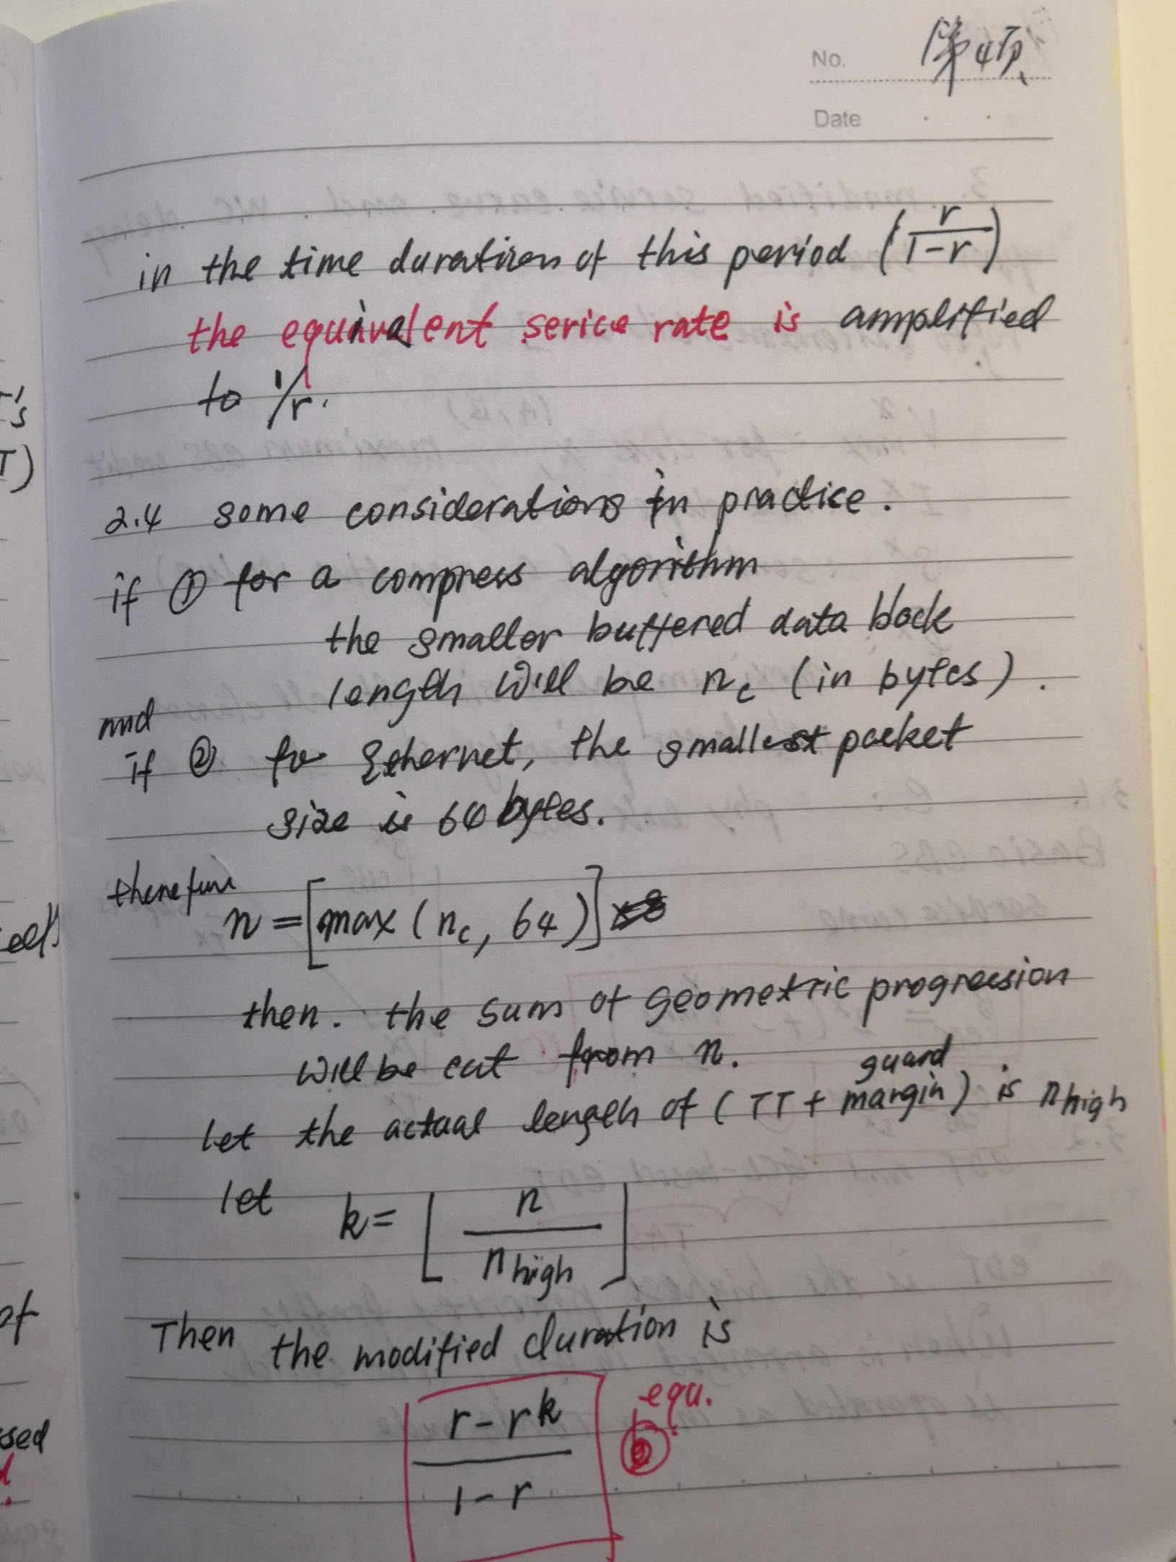

Page 5

**3 THE MODIFIED SERVICE CURVE AND THE WC DELAY BOUND IMPROVED BY OUR CaF**

**3.1 A basic notation to CBS**

**3.2 CDT and GCL-based CDT**

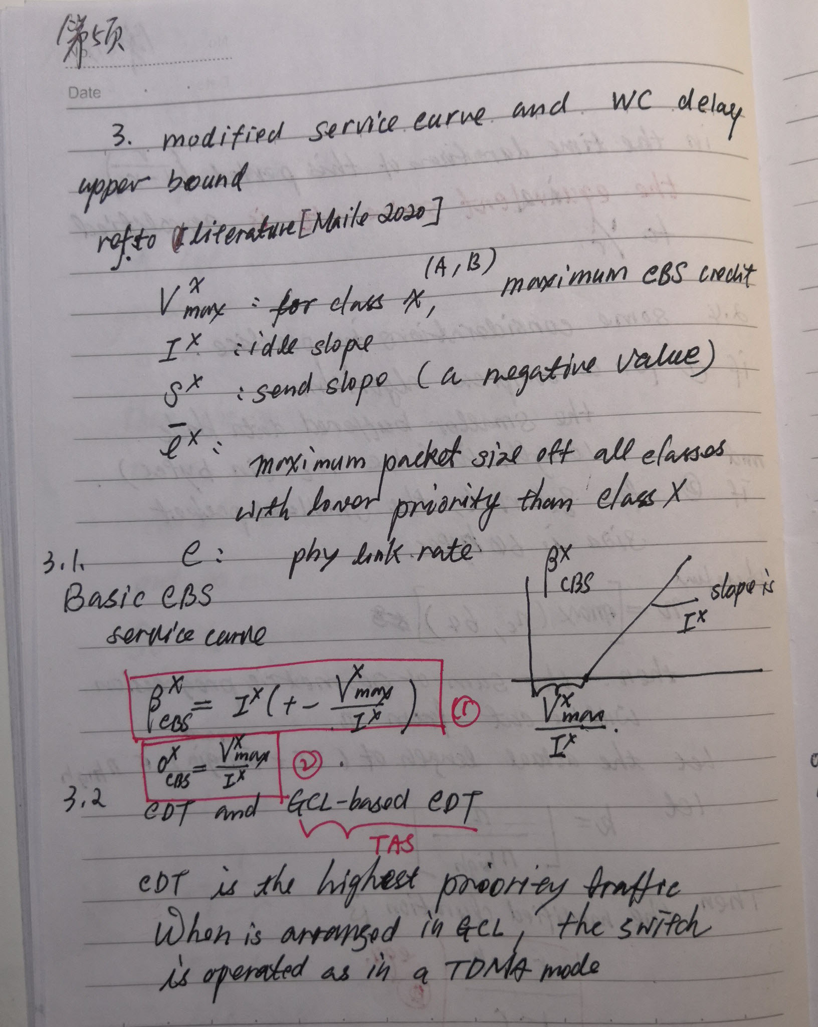

Page 6

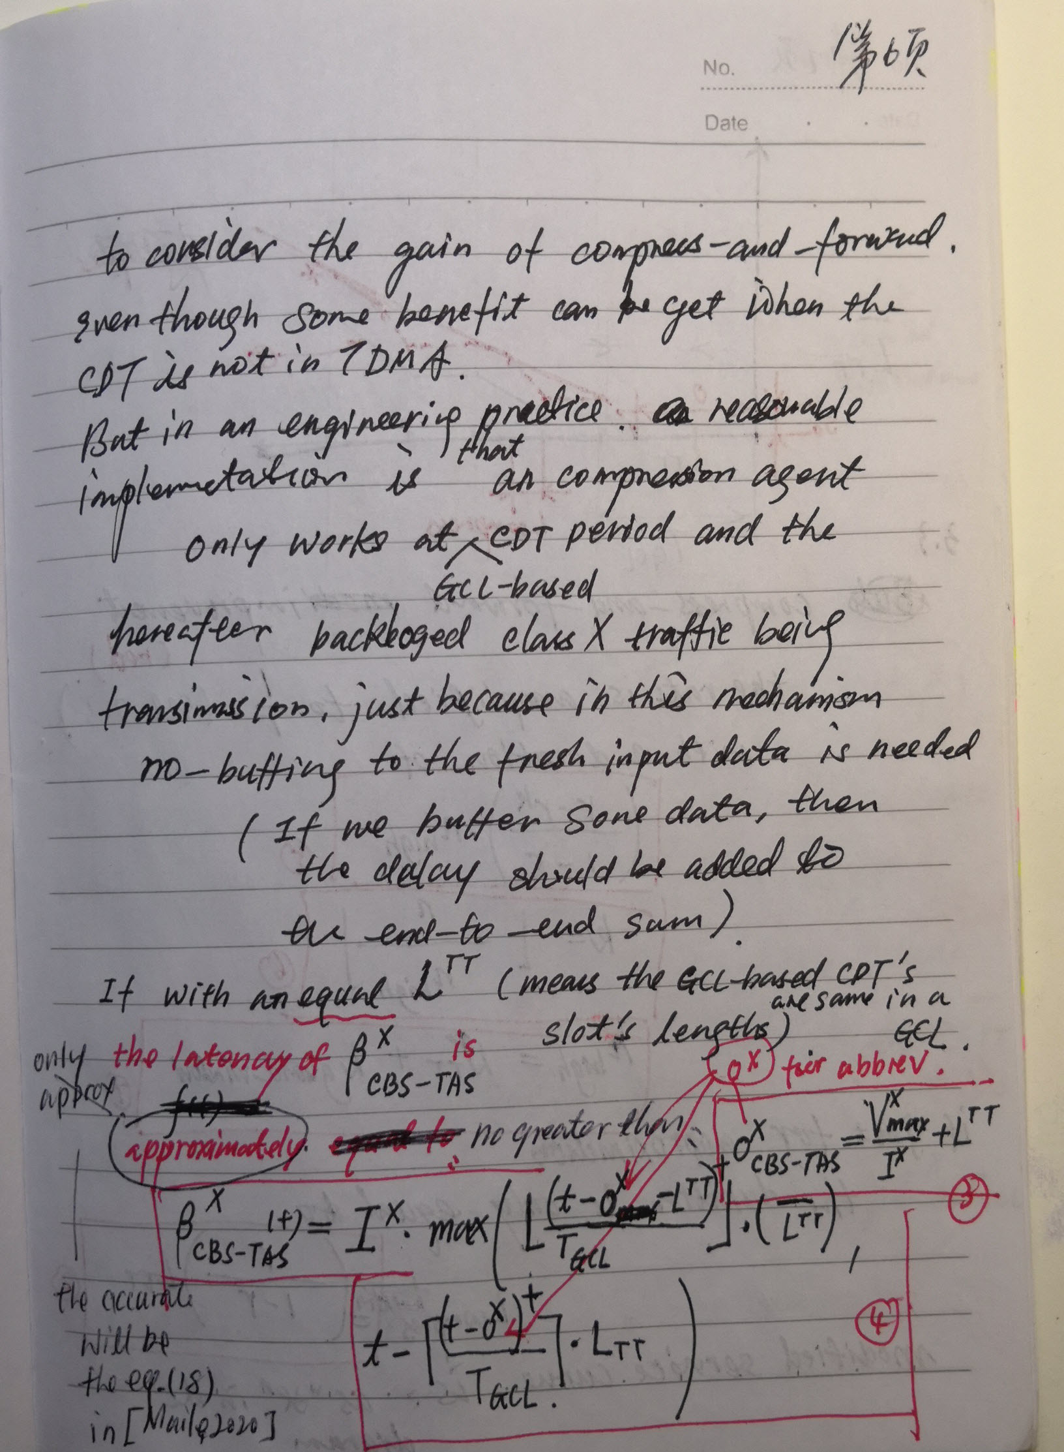

Page 7

**3.3 Improvement for delay shinking**

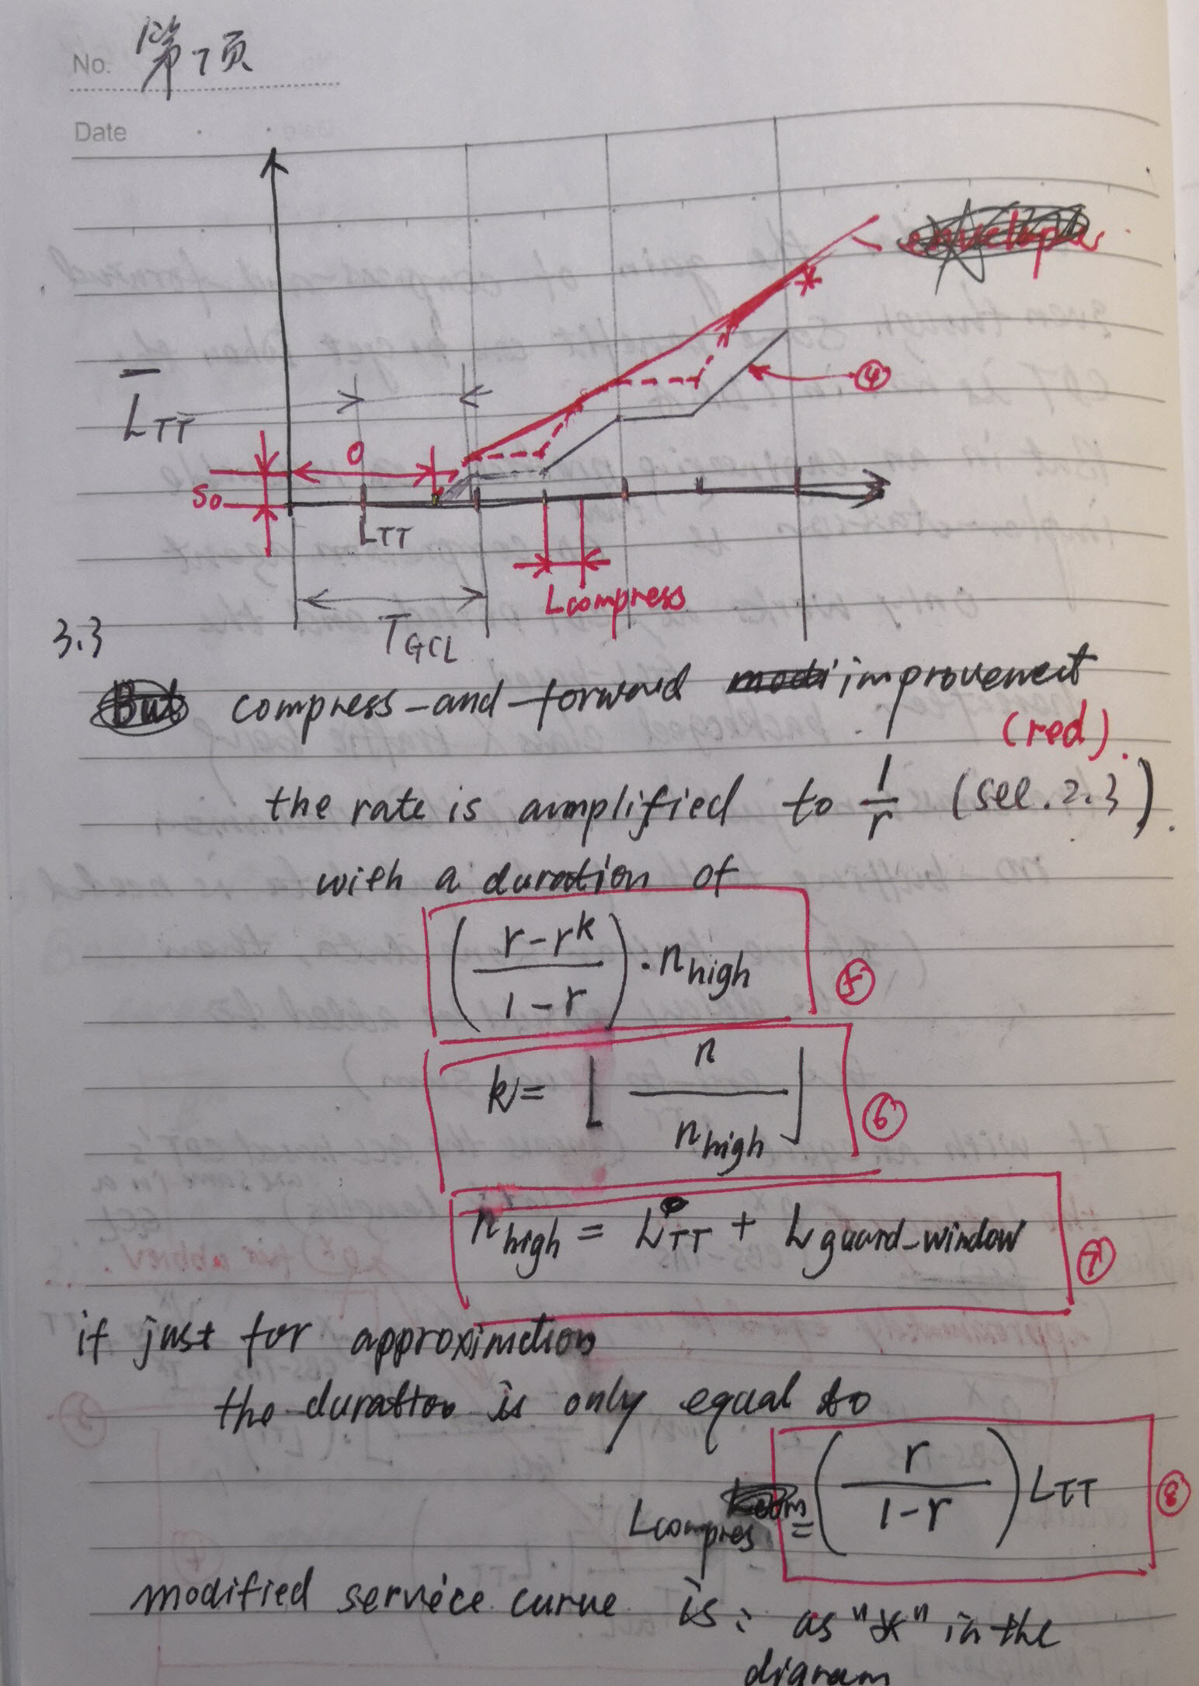

Page 8

**4 BENEFIT by the analysis of the (sigma, rho) model case study**

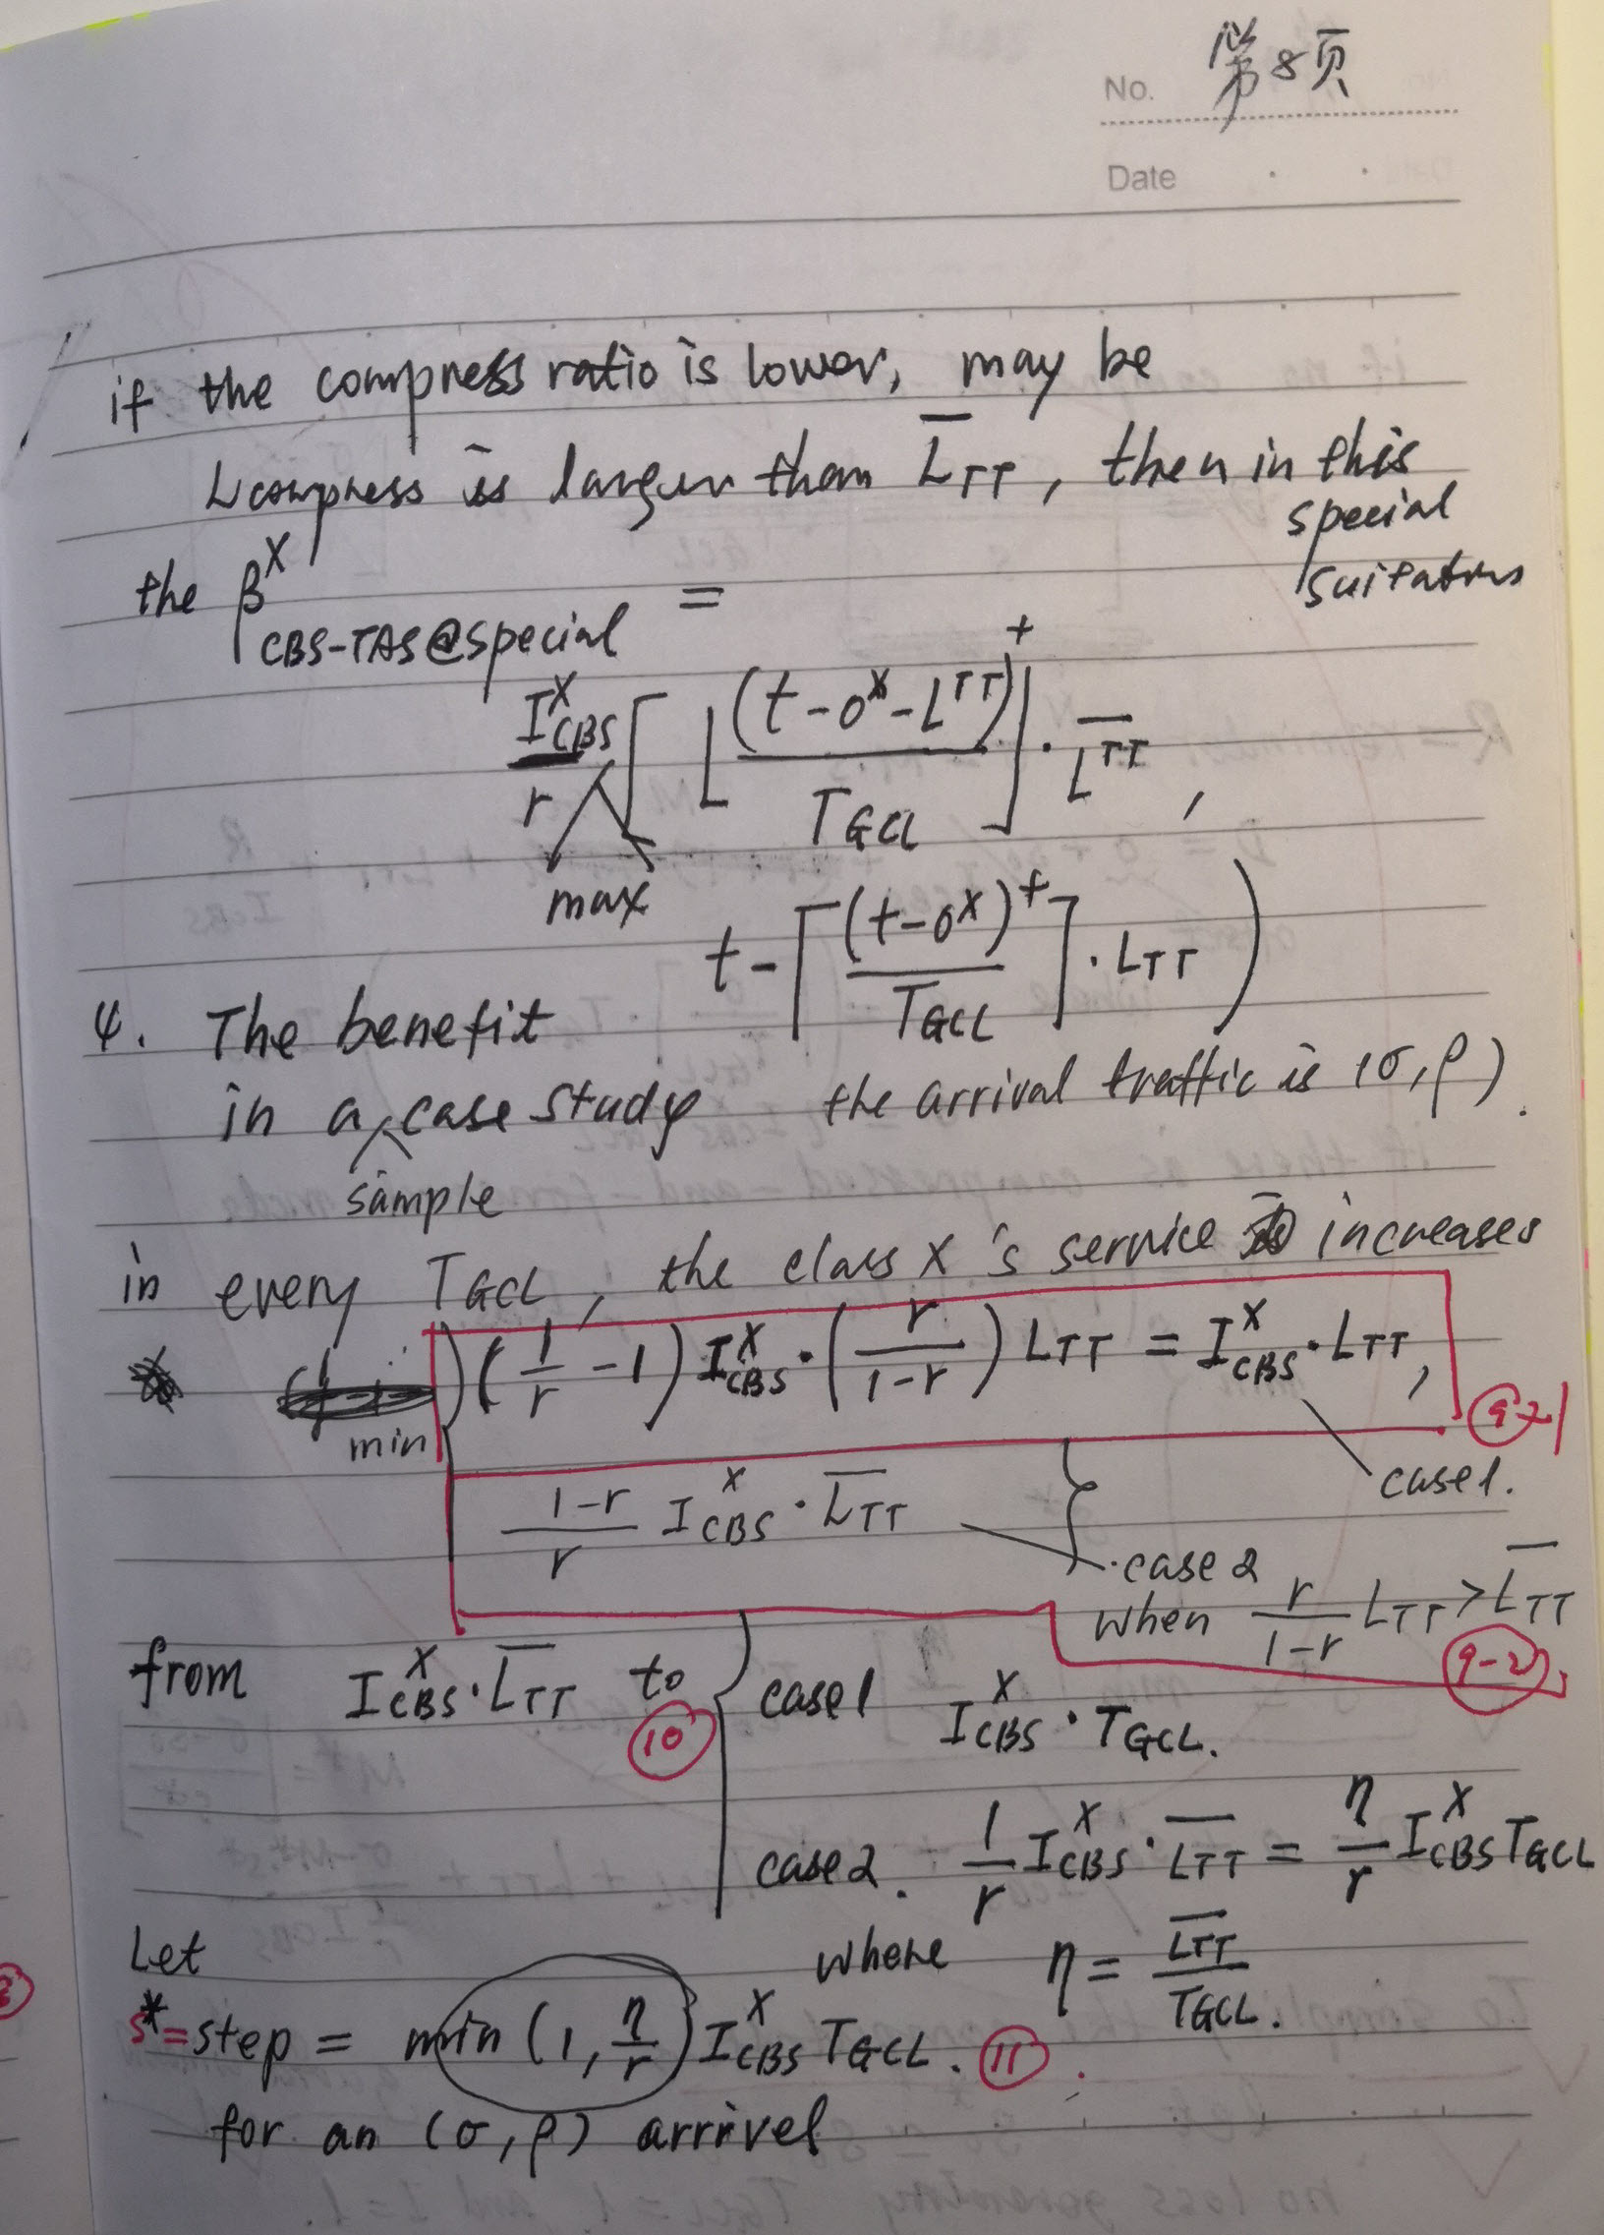

Page 9

**4.1 a simple case to provide service for (sigma, rho) arrival**

To simplify the analysis and no loss of generalization, let

TGCL= 1 (unit “1” for time)

and let *I*CBS = 1 (unit “1” for rate or for slope)

Then the arrival  i.e. ( sigma , rho ) model will be normalized as 

**4.2 duration of compress-amplified rate**

Without consider the minimum block needed to compress, and assuming the guard margin of an is zero in pessimism, the duration with compress-amplified rate in  is  .

When  , ; therefore with the rate  in the whole .;

otherwise,  ( compression ratio is less than the ratio of CBS in a GCL period ), 

|  |
| --- |
| Appendix:  Function y(x)=x/(1-x) = 1/(1-x) – 1 is a strictly increased function when x in [0,1].  The figure as below  So  deduces  ( hence ) |

**4.3 decreased delay with a simplified assumption**

Note: to compare service curves of the original and of the compressed, “*s*0* = *s*0 “ can also be considered in pessimism.



Page 11

**4.4 case studies for some typed scenarios**

Example 1:  ( in this figure, r=3/4, eta=2/3 )



Note: get inversion functions of service curves.



Example 2:  ( in this figure, r=5/8, eta=2/3 ) ( and  )



Note: get inversion functions of service curves.



Example 3:  ( in this figure, r=1/2, eta=2/3 ) ( and  )



Note: get inversion functions of service curves.



Example 4:  ( in this figure, r=1/3, eta=2/3 ) ( and  )





Different *r* parameters for time_cost and decreased delay







When r is less than eta (in this case, r=0.65, eta=0.667) , the decreased delay will be linear in approximated linear slope in a long term. ( Note: the inversion of service curves is printed in yellow color in the above

Page 16

**4.5 case studies with the assumption of 4.2 for comparisons**

If for approximation, let s0=s0*, the figures become:

For “Example 1”: 



For “Example 2”:  ( in this figure, r=5/8, eta=2/3 ) ( but  )



For “Example 3”:  ( in this figure, r=1/2, eta=2/3 ) ( but  )

For “Example 4”:  ( in this figure, r=1/3, eta=2/3 ) ( and  )









When r is less than eta (in this case, r=0.65, eta=0.667) , the decreased delay will be in a linear slope in a long term.

**5 CONCLUSIONS**

|  |  |
| --- | --- |
| Compress ratio *r* | Benefit to shorten the delay with a  model arrival |
|  | From  , the worst case delay decreasedapproximately in a long term when the burstiness  accumulates every  after .  And if the rational value of  is written as  the worst case delay reduces times of  every the burstiness  accumulates every  after . |
|  | From  , the worst case delay decreased  approximately in a long term when the burstiness  accumulates every  after . |

Advantage: if , the compress-and-forward mechanism can shrink the worst-case delay so that it can at least cease the blocking delay by TDMA-based CDT in a certain duration that is just larger than one *T*GCL ( in some cases, larger than  is enough).

Disadvantage: the compress-and forward can only perform one time because the compress ratio only depends the entropy of data from the information source.